Amanda Som

CS 255 System Design Document Template

UML Diagrams

UML Use Case Diagram
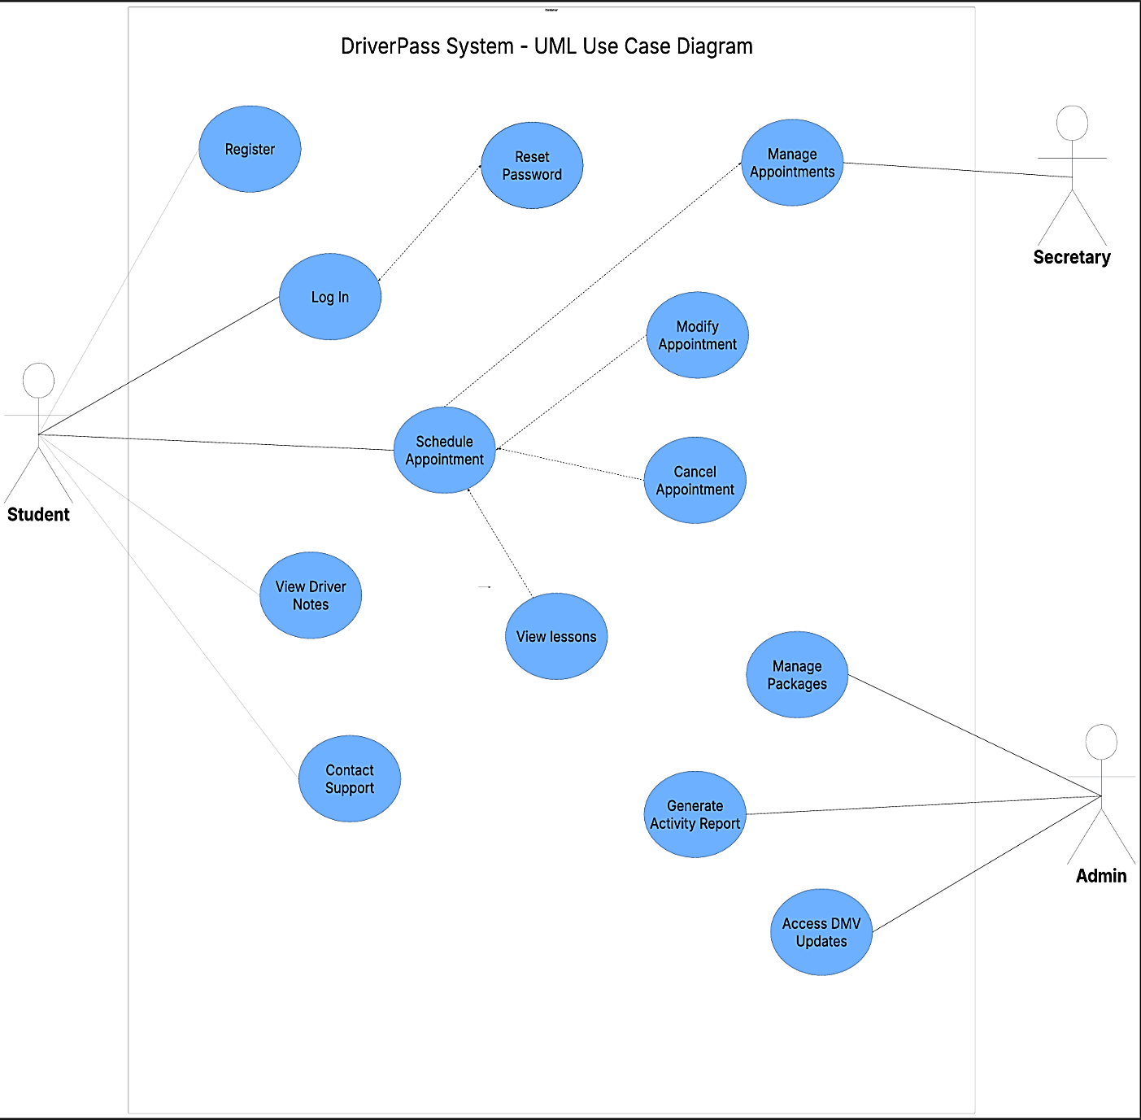

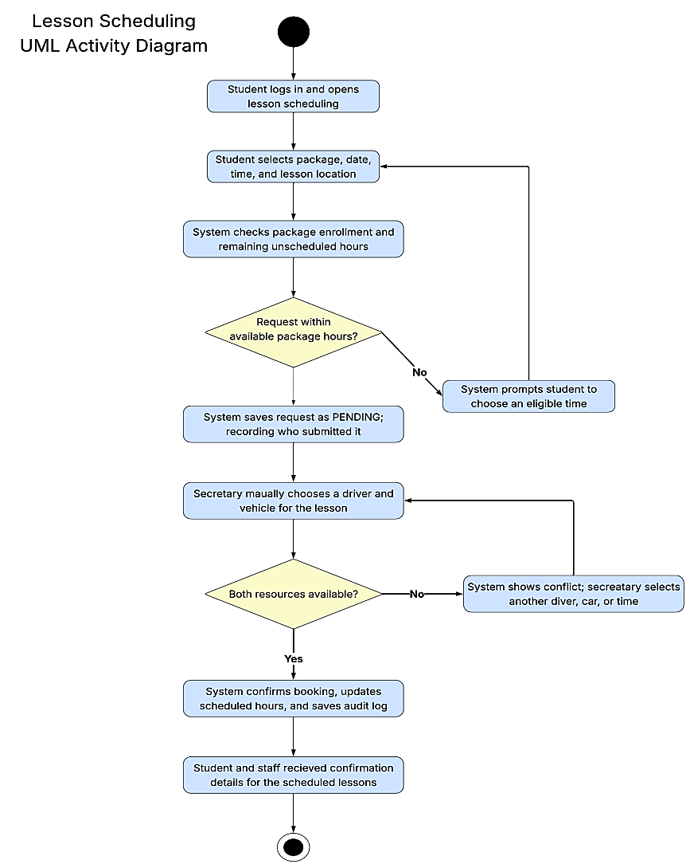
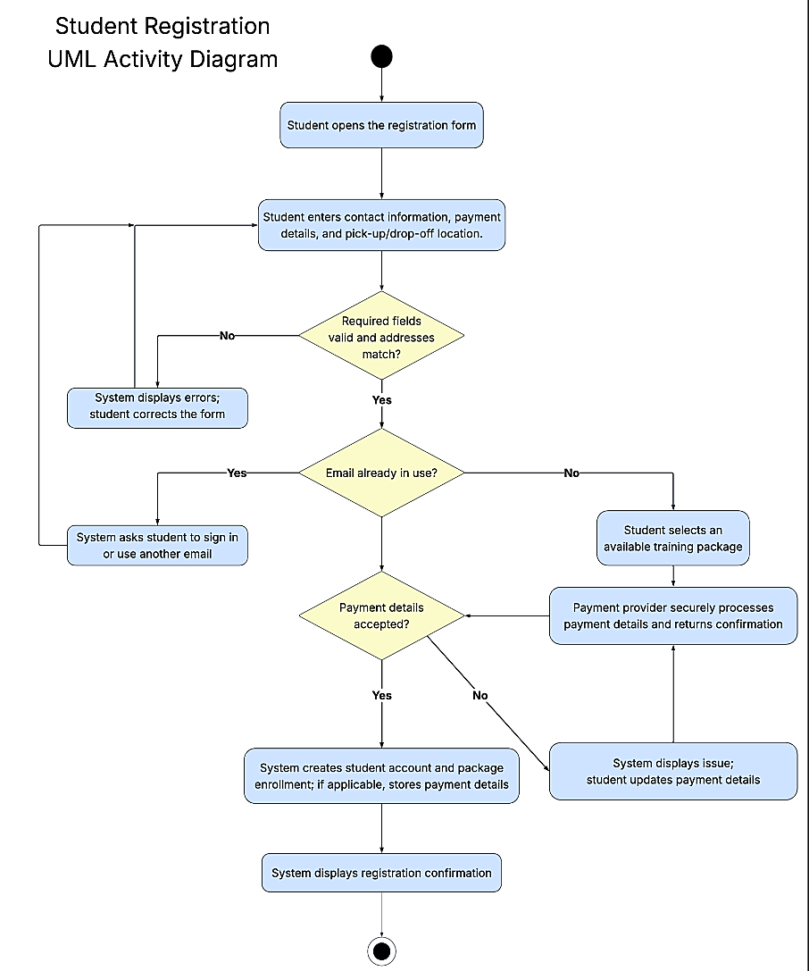
UML Activity Diagrams

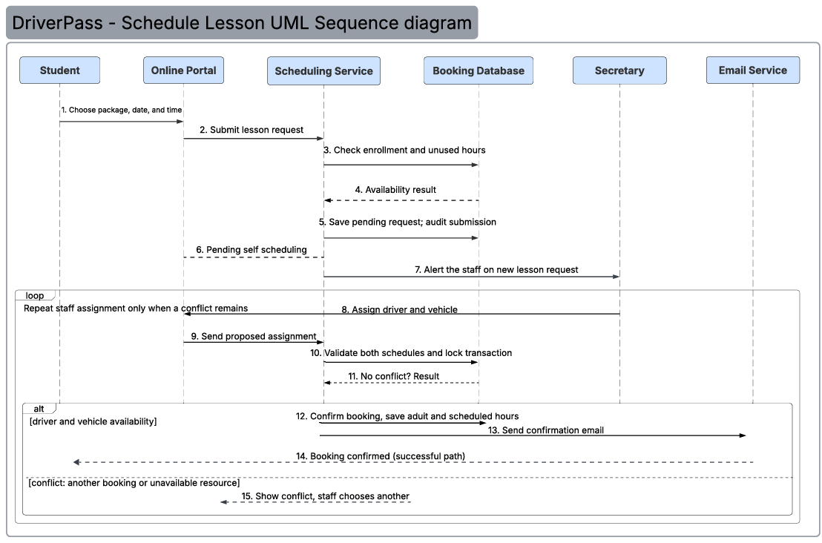
UML Sequence Diagram

UML Class Diagram
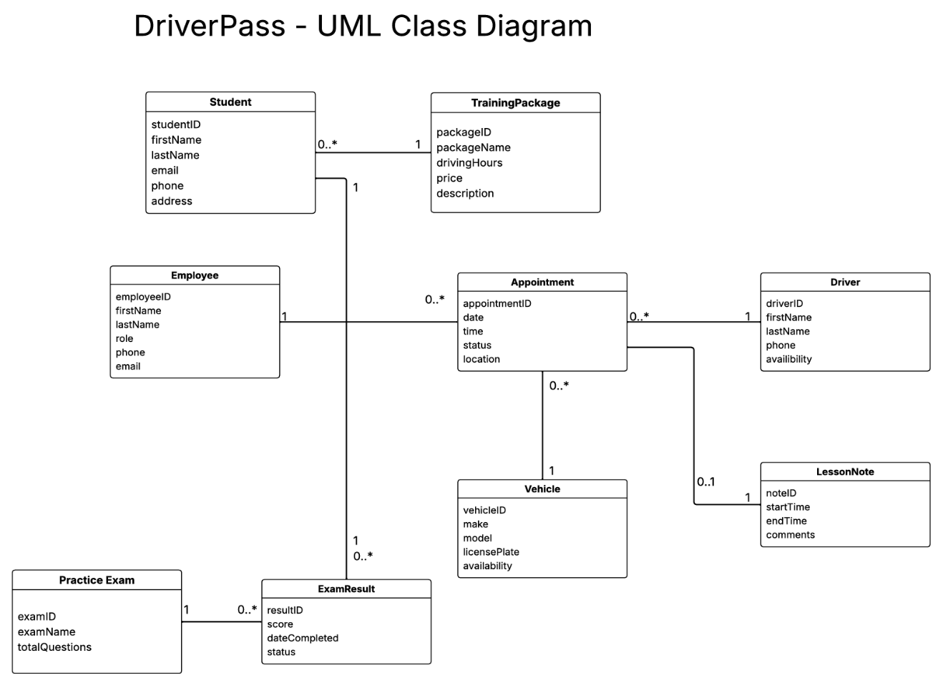

Technical Requirements
The DriverPass system will require hardware, software tools, and infrastructure that support various functions, including online registration, lesson scheduling, practice exams, and administrative tasks. Since it will function as a cloud-based system, students and employees should have the ability to access it from different devices without needing to install additional software.

Hardware Requirements
DriverPass employees require computers or laptops with reliable internet access, to manage customer information, appointments, and daily operations. Students can access their accounts from desktops, laptops, tablets, or mobile devices, while drivers can use mobile devices to view their schedules and enter lesson notes. Since the system will be hosted in the cloud, DriverPass will not need to maintain physical servers. The cloud provider will be responsible for the server hardware and data storage.

Software Requirements
The system, a web-based application, will be accessible through browsers like Google Chrome and Microsoft Edge. A relational database will be needed to store customer information, appointments, driver and vehicle assignments, training packages, and practice exam results. The system will also need software to support account authentication, password resets, payment processing, and scheduling updates. These functions should work together to prevent double-booking and ensure that information remains current and accurate.

Tools Requirements
To build, test, and maintain the DriverPass system, development tools will be required. Lucidchart can be used to create UML diagrams, while programming and testing tools will help developers identify errors and make updates. Administrative tools should allow authorized employees to manage accounts, permissions, and system settings without changing the code. Reporting tools should also allow users to download reports in formats such as Excel, while monitoring tools will help the IT officer identify system errors and security issues.

Infrastructure Requirements
DriverPass requires a secure, multi-user cloud hosting hub that supports simultaneous access from multiple devices. To protect transmitted information, the system should employ encryptions, and to restrict user access, it should implement role-based access controls. Regular backups and recovery procedures will also be necessary to protect customer and scheduling information. The infrastructure should support real-time appointment updates and allow DriverPass to receive updated DMV rules, policies, and test information when available.

